Course Code: GRC101
Course Title: Introduction to GRC Engineering
Student Name: Imelda Sanya
Registration Number: C11/26/CGRCE/17576
Email: sanyanabs16@gmail.com
Cohort/Batch: 11
Week 2: Scenario and Practical Lab Assignment

NexaLearn Digital Services Limited

Part 1: Context, Stakeholder and Objective Analysis

1.0 Introduction
NexaLearn Digital Services Limited is a Nigerian education technology (EdTech) company that provides online professional training, digital assessments and certification services to approximately 18,000 learners across Africa, including around 600 learners residing in the European Economic Area (EEA). The organization employs 68 staff and relies on several cloud-based services, including Microsoft 365, a cloud-hosted learning platform, a payment gateway, a third-party customer support platform and an outsourced software development vendor. The Board has also approved the implementation of an AI-assisted admissions screening system within the next three months to support business growth.
While the company's growth strategy presents significant opportunities, the scenario identifies several governance, risk and compliance weaknesses. These include shared privileged accounts, delayed user offboarding, excessive user permissions, insecure cloud storage configurations, weaknesses in third-party contracts and uncertainty regarding applicable regulatory requirements. These issues expose the organization to cybersecurity, privacy, operational and regulatory risks that could hinder its strategic objectives.
This assessment evaluates NexaLearn's governance environment, identifies key risks and recommends practical controls that support regulatory compliance, improve operational resilience and enable secure business growth.

1.1 Business Objectives
The Board has established five strategic objectives that guide the organization’s future direction:
Objective | Business Goal | GRC Consideration
Growth | Increase active learners by 40% within 12 months | Expansion must not compromise security or compliance.
Trust | Reduce serious security and privacy incidents to zero | Strong governance and proactive risk management are required.
Availability | Maintain 99.9% uptime for learner-facing services | Business continuity and resilient cloud operations are essential.
Compliance | Achieve ISO/IEC 27001 certification readiness | Security controls must be documented, implemented and monitored.
Innovation | Deploy an AI-assisted admissions screening solution with human oversight | AI governance, fairness, accountability and transparency should be embedded from the outset.
These objectives demonstrate that governance and cybersecurity are business enablers rather than purely technical functions. Effective GRC practices will support sustainable growth while maintaining stakeholder trust.

1.2 Key Internal Stakeholders

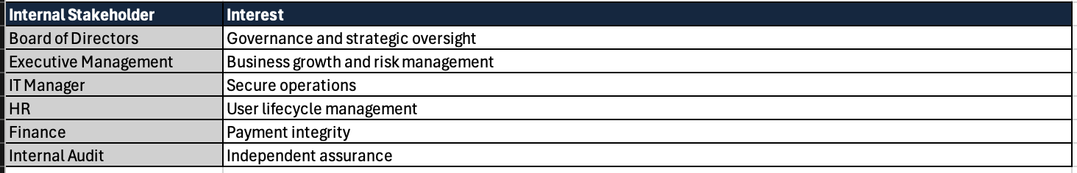

1.3 External Stakeholders
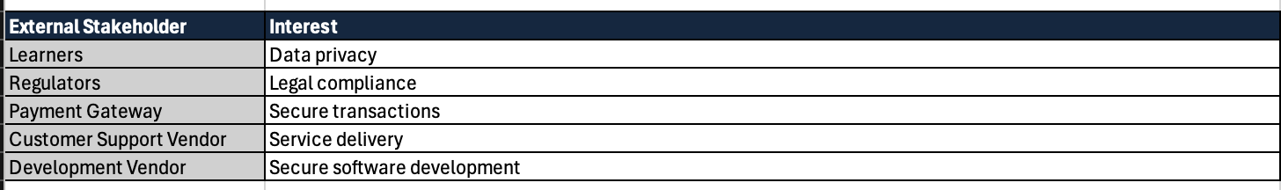

1.4 Critical Business Processes
Several operational processes are essential to the continued success of NexaLearn:
- Learner registration and admissions
- Online course delivery
- Digital assessments and certification
- Payment processing
- Identity and access management
- Customer support operations
- Software development and deployment
- Cloud infrastructure management
- Backup and disaster recovery
- AI-assisted admissions screening
Disruption to any of these processes could affect service availability, learner trust and regulatory compliance.

1.5 Critical Information Assets
The organization processes valuable information assets that require appropriate protection:
- Learner personal information
- Assessment and examination records
- Payment information
- Employee records
- Identity and access credentials
- Cloud storage repositories
- AI decision data
- Audit logs
- Security monitoring data
- Backup repositories
These assets should be classified according to their sensitivity and protected through appropriate technical and administrative controls.

1.6 Technology Dependencies
NexaLearn depends on several technologies to deliver its services:
- Cloud-hosted learning platform
- Microsoft 365
- Customer support platform
- Payment gateway
- Outsourced software development services
- Cloud identity services
- Cloud storage
- Internet connectivity
- Security monitoring solutions
- Backup and recovery services
Failure or compromise of any dependency may significantly impact service availability and business continuity.

1.7 Stakeholder Expectation Conflicts
As the organization grows, competing stakeholder expectations require careful governance.
Growth versus Security
Executive management aims to increase learner enrolment by 40% within twelve months, while the security function prioritizes strong controls and risk reduction. Accelerated deployment of new technologies without adequate governance may introduce vulnerabilities. A risk-based change management process should balance innovation with security.
Privacy versus Business Operations
Learners expect their personal information to remain confidential, whereas operational teams require access to learner data to deliver services. Access should therefore be governed using the principles of least privilege, role-based access control and periodic access reviews.
Innovation versus Regulatory Compliance
Management intends to deploy an AI-assisted admissions screening system within three months, while regulators and learners expect fairness, transparency and human oversight in automated decision-making. Establishing an AI governance framework aligned with ISO/IEC 42001 will help ensure ethical AI deployment while maintaining compliance.

Personal Reflection
From my perspective as a Software Quality Engineer with an interest in cybersecurity, this scenario highlights the importance of validating security controls through evidence rather than assuming they operate effectively. Effective governance requires continuous monitoring, automation where appropriate and regular verification of identity, access and operational controls to ensure that compliance is maintained as the organization grows.

Part 2: Compliance Obligations Register

2.0 Compliance Obligations Assessment
NexaLearn operates in a highly regulated environment where personal information, payment transactions, cloud services and artificial intelligence are integral to business operations. As the organization expands across multiple African countries and serves learners within the European Economic Area (EEA), it must comply with a combination of legal requirements, contractual obligations, internationally recognized standards and industry best practices.
Not every framework mentioned in the scenario is legally mandatory. Some become applicable because of the organization’s business activities, while others are adopted voluntarily to improve governance or demonstrate good security practices. Understanding these distinctions enables management to prioritize compliance efforts effectively.

2.1 Compliance Obligations Register
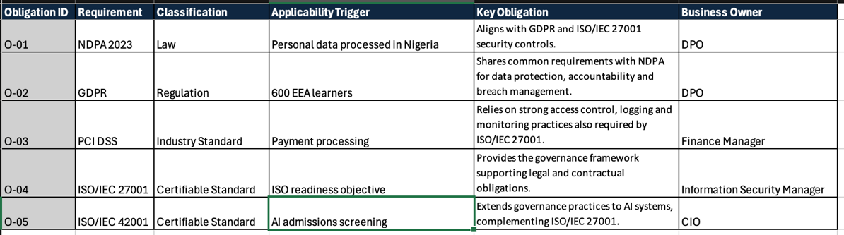

2.2 Applicability Analysis

Nigeria Data Protection Act (NDPA) 2023
The NDPA is directly applicable because NexaLearn processes the personal information of learners, employees and customers within Nigeria. The evidence indicates that learner records were exposed through a publicly accessible storage container, highlighting the need for stronger privacy controls and incident response procedures. Compliance with the NDPA requires the organization to implement appropriate technical and organizational measures to safeguard personal information and manage data breaches effectively.

General Data Protection Regulation (GDPR)
Although NexaLearn is based in Nigeria, the GDPR applies because the company provides services to approximately 600 learners residing in the European Economic Area. The organization must therefore protect the rights of EU data subjects, implement appropriate security controls and assess whether any security incident triggers mandatory breach notification requirements. The incident involving publicly accessible learner records could have GDPR implications if EU residents were affected.

PCI DSS
NexaLearn uses a payment gateway to process learner payments. While the payment provider may manage much of the payment infrastructure, NexaLearn remains responsible for ensuring that payment information is handled securely within its environment and that responsibilities shared with the payment provider are clearly understood. PCI DSS therefore applies as an industry and contractual requirement rather than a law.

ISO/IEC 27001
Management has identified ISO/IEC 27001 certification readiness as a strategic objective. Achieving certification requires the organization to implement an Information Security Management System (ISMS), conduct risk assessments, define security policies, assign responsibilities and continually monitor and improve security controls. This standard provides the governance foundation needed to address many of the weaknesses identified in the scenario.

ISO/IEC 42001
NexaLearn intends to introduce an AI-assisted admissions screening solution within three months. Because AI systems may affect individuals through automated decision-making, the organization should establish governance mechanisms that ensure fairness, transparency, accountability and meaningful human oversight. ISO/IEC 42001 provides a structured framework for managing AI responsibly throughout its lifecycle.

NIST Cybersecurity Framework (CSF) 2.0
NIST CSF 2.0 is not legally mandatory but serves as a recognized best practice framework for strengthening cybersecurity governance. Its functions i.e. Govern, Identify, Protect, Detect, Respond and Recover can help NexaLearn organize its cybersecurity programme, improve risk management and support ISO/IEC 27001 implementation.

2.3 Overlap Between the Requirements
Several of these obligations complement one another rather than operating independently:
Requirement | Primary Focus | Relationship
NDPA 2023 | Privacy and protection of personal data in Nigeria | Aligns with GDPR and ISO/IEC 27001 security controls.
GDPR | Privacy rights for EEA residents | Shares common requirements with NDPA for data protection, accountability and breach management.
PCI DSS | Secure payment processing | Relies on strong access control, logging and monitoring practices also required by ISO/IEC 27001.
ISO/IEC 27001 | Information security management | Provides the governance framework supporting legal and contractual obligations.
ISO/IEC 42001 | AI governance | Extends governance practices to AI systems, complementing ISO/IEC 27001.
NIST CSF 2.0 | Cybersecurity best practice | Helps operationalize many of the controls required by the other obligations.
This overlap allows NexaLearn to implement a unified control environment, where a single control such as multi-factor authentication, access reviews or incident response can satisfy multiple regulatory and industry requirements. This approach reduces duplication and improves governance efficiency.

Personal Reflection
In my experience as a Software Quality Engineer with an interest in cybersecurity, understanding why a requirement applies is just as important as knowing what it requires. During security testing, I have found that many controls such as access management, logging and evidence collection can simultaneously support compliance with multiple frameworks. Adopting a common control approach enables organizations to reduce duplicated effort, simplify audits and maintain a more consistent security posture.

Part 3: Risk Register and Risk Appetite

3.2 Risk Register

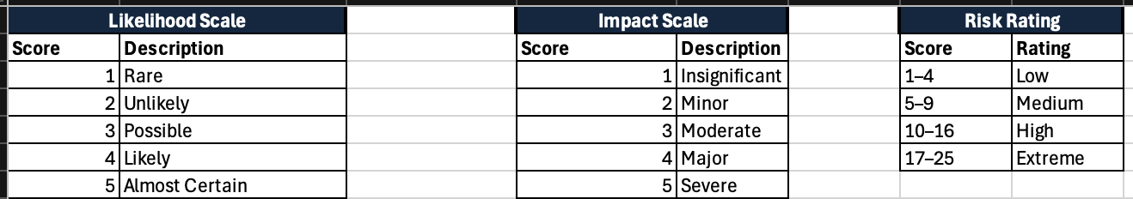

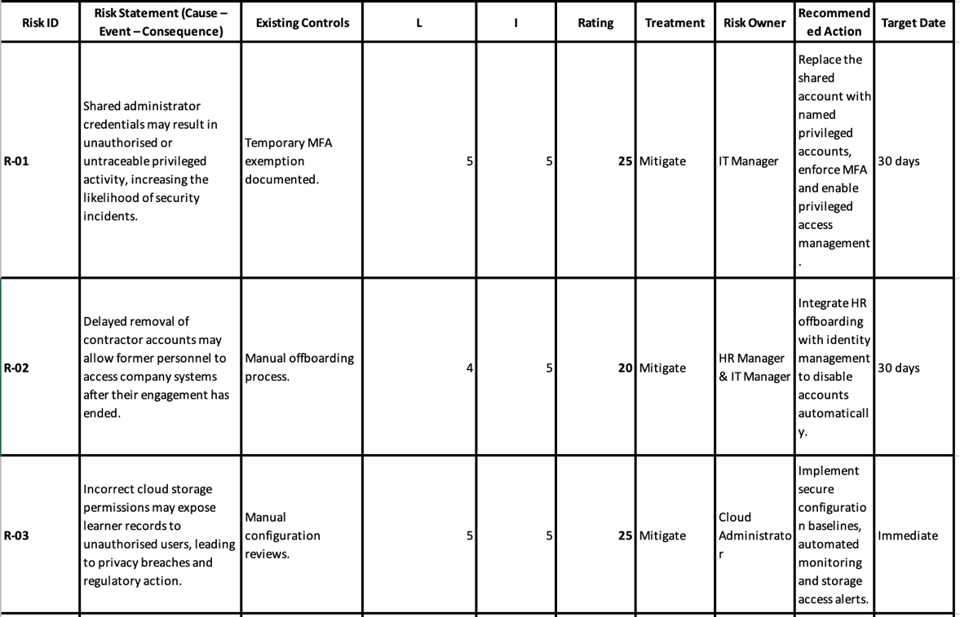

3.3 Risk Heat Map
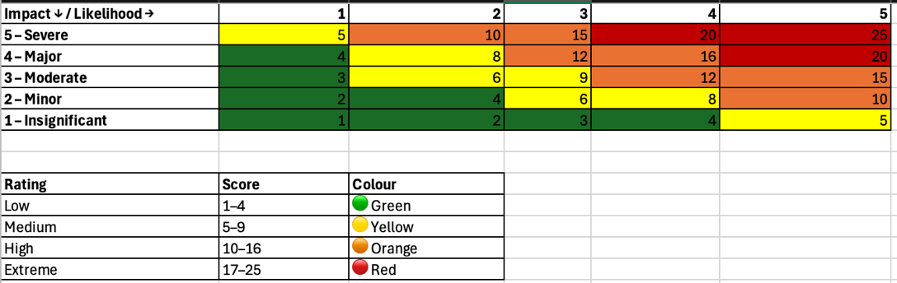
The heat map illustrates the distribution of identified risks based on their assessed likelihood and business impact. Risks located in the red zone require immediate management attention and are prioritized within the action plan.

3.4 Risk Assessment Summary
The assessment identified eight significant risks affecting identity management, cloud security, third-party governance, incident response and AI adoption. Two risks shared administrator accounts (R-01) and exposed cloud storage (R-03) received the highest rating because they present an immediate threat to confidentiality and accountability.
Third party governance also requires attention. Although the customer support vendor has obtained independent assurance through a SOC 2 Type II report, the absence of contractual clauses covering data processing, breach notification and exit arrangements increases the organization’s legal and operational exposure. Reviewing assurance reports without formally documenting the findings also limits management's ability to demonstrate due diligence.
The planned AI admissions system introduces a different type of risk. While it supports the organization’s innovation objectives, deploying the solution without documented governance or human oversight may result in unfair decisions, reduced transparency and increased regulatory scrutiny. Addressing these concerns before implementation will help balance innovation with responsible use of AI.

Assumptions
The following assumptions were made because the scenario does not provide complete operational details:
- NexaLearn does not currently operate a Privileged Access Management (PAM) solution.
- User provisioning and offboarding are performed manually.
- Cloud storage configuration reviews are not automated.
- AI governance policies have not yet been developed because the admissions system is still in the planning stage.
- Vendor risk assessments are performed informally rather than through a structured programme.

Part 4: Three Lines Model and RACI Design

4.0 Governance and Accountability
One of the recurring themes in the NexaLearn scenario is that responsibilities are not clearly defined. Shared administrator accounts, delayed user offboarding and overdue audit findings suggest that accountability has become blurred between operational teams and oversight functions. As the organization continues to grow, assigning clear ownership will be essential to ensure that governance activities are carried out consistently and that risks are managed at the appropriate level.
Adopting the Three Lines Model provides a structured way of separating operational responsibilities from oversight and independent assurance.

4.1 Three Lines Model

First Line – Operational Management
The first line owns and manages risk as part of day-to-day business operations. Managers are responsible for implementing controls, following approved policies and ensuring that risks are identified and addressed promptly.
Key responsibilities
- Provision and remove user accounts.
- Maintain secure cloud configurations.
- Protect learner information.
- Manage vendor relationships.
- Perform backup testing.
- Escalate security incidents.
- Implement AI governance requirements during system development.
Responsible teams
- IT Operations
- Human Resources
- Finance
- Cloud Administration
- Business Unit Managers
- Procurement
- AI Project Team

Second Line – Risk, Compliance and Security
The second line provides oversight, develops policies and monitors whether controls are operating effectively. Rather than carrying out operational tasks, these teams advise management, assess compliance and support risk management activities.
Key responsibilities
- Develop security and privacy policies.
- Maintain the enterprise risk register.
- Monitor compliance with NDPA, GDPR and PCI DSS.
- Conduct vendor risk assessments.
- Coordinate security awareness activities.
- Review AI governance controls.
- Monitor key risk indicators and compliance metrics.
Responsible teams
- Information Security
- Risk Management
- Compliance
- Data Protection Officer (DPO)

Third Line – Internal Audit
Internal Audit provides independent assurance to the Board that governance, risk management and internal controls are functioning as intended. To preserve independence, Internal Audit should not own or operate controls.
Key responsibilities
- Audit identity and access management.
- Review incident response effectiveness.
- Assess compliance with policies and standards.
- Verify remediation of audit findings.
- Report significant governance issues to the Audit Committee.

4.2 Responsibility Matrix (RACI)
Activity | Business Unit Manager | IT Operations | Risk & Compliance | Internal Audit | Executive Management
User Access Management | A | R | C | I | I
Privileged Access Reviews | A | R | C | I | I
Incident Response | A | R | C | I | I
Privacy Compliance | C | R | A | I | I
Vendor Risk Management | A | C | R | I | I
AI Governance | A | R | C | I | I
Annual Risk Assessment | C | C | R/A | I | I
Internal Audit Reviews | I | I | C | R/A | I
Legend
- R – Responsible (performs the work)
- A – Accountable (owns the outcome)
- C – Consulted (provides input)
- I – Informed (kept updated)

4.3 Governance Issues Identified
The evidence provided highlights several governance weaknesses that should be addressed.

Shared Emergency Administrator Account
The emergency administrator account is used by three technical staff members. This makes it difficult to determine who performed privileged actions, reducing accountability and weakening forensic investigations following an incident. Shared privileged accounts should be replaced with individually assigned administrative accounts supported by multi-factor authentication and privileged access management.

Delayed User Offboarding
A contractor account remained active for 37 days after the contract ended. This indicates a breakdown between Human Resources and IT during the offboarding process. A formal joiner, mover and leaver (JML) process with automated account deprovisioning would reduce the likelihood of former personnel retaining access to organizational systems.

Finance Officer Segregation of Duties
The Finance Officer has permission to both approve payment refunds and reconcile transactions. Combining these responsibilities creates a segregation of duties (SoD) conflict because the same individual can authorise and verify financial transactions without independent oversight. This increases the risk of fraudulent refunds, financial manipulation and undetected errors.
A more appropriate control would separate these responsibilities between different individuals or require secondary approval for high-value refunds. Regular access reviews should also verify that financial permissions remain appropriate.

Overdue Audit Findings
The internal audit report identified repeated delays in closing access review and backup testing findings. This suggests that management is not effectively tracking remediation activities or holding control owners accountable. Introducing formal action tracking, target completion dates and periodic reporting to executive management would improve governance and ensure that identified weaknesses are addressed within agreed tmelines.

Practical Observation
A common mistake organization make is assuming that security is solely the responsibility of the IT department. In practice, governance is most effective when business owners are accountable for the risks within their areas, while security and compliance teams provide guidance and oversight. This approach encourages risk ownership across the organization and aligns with the Three Lines Model.

Part 5: Common Control Framework (CCF)

5.0 Common Control Framework
A Common Control Framework (CCF) brings together controls that satisfy multiple regulatory, contractual and business requirements. Instead of creating separate controls for each law or standard, a single well-designed control can address overlapping obligations such as NDPA, GDPR, ISO/IEC 27001, PCI DSS and NIST CSF.
For NexaLearn, adopting a CCF will reduce duplication, simplify audits and create a more consistent approach to governance. It will also help management monitor control effectiveness as the organisation expands into new markets and introduces AI-assisted admissions.

5.1 Common Control Framework
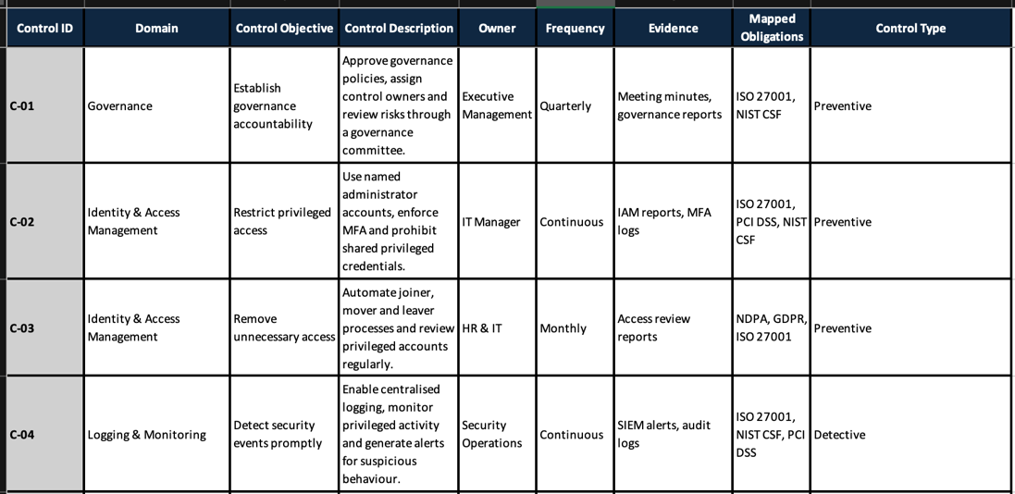

5.2 Control Mapping Rationale
The controls have been designed to satisfy more than one requirement wherever possible. For example:
- C-02 (Privileged Access Management) supports ISO/IEC 27001 by strengthening identity and access management, helps PCI DSS protect administrative access to payment environments and aligns with the Protect function of NIST CSF.
- C-05 (Data Protection) supports both NDPA and GDPR because each requires organizations to protect personal information through appropriate technical and organizational measures.
- C-06 (Incident Response) contributes to legal compliance by enabling timely investigation, containment and breach notification where required under NDPA and GDPR.
- C-09 (AI Governance) addresses the organization’s planned AI admissions tool by ensuring that decisions are transparent, monitored and subject to human oversight before affecting learners.
This mapping reduces duplication and makes it easier for NexaLearn to demonstrate compliance during internal audits or certification assessments.

5.3 Control Inheritance
Not every security control is implemented directly by NexaLearn. Some controls are inherited from cloud and SaaS providers, although responsibility for oversight remains with the organization.
Service | Inherited Controls | Customer Responsibility
Microsoft 365 | Physical security, platform availability, infrastructure maintenance | Identity management, conditional access, user lifecycle management and data classification
Cloud Hosting Provider | Data Centre security, hardware maintenance, network resilience | Secure configuration, storage permissions, encryption settings and monitoring
Payment Gateway | Payment processing infrastructure and core PCI DSS controls | User access management, integration security and contractual oversight
Customer Support Platform | Application hosting and platform availability | Vendor due diligence, contract management, access reviews and data protection obligations
This shared responsibility model is particularly important for cloud services. While providers manage the security of their platforms, NexaLearn remains accountable for securing the data and configurations it controls.

5.4 Key Observations
The proposed Common Control Framework addresses the governance weaknesses identified in the scenario. Several controls respond directly to the evidence:
- C-02 addresses the risks associated with shared administrator accounts.
- C-03 improves the delayed removal of user accounts.
- C-05 reduces the likelihood of publicly exposed storage containers.
- C-07 strengthens vendor oversight by requiring formal security clauses and documented reviews of assurance reports.
- C-09 establishes governance before the AI-assisted admissions system is deployed.
By implementing these controls as a coordinated framework rather than isolated activities, NexaLearn can improve governance, simplify compliance reporting and support its strategic objectives for growth, trust and innovation.

Part 6: Practical Control Testing

6.0 Control Testing Approach
Control testing was performed using the evidence provided in the scenario to assess whether key controls are suitably designed and operating as intended. Three areas were selected because they present the highest level of risk to NexaLearn:
- Identity and privileged access management
- Incident detection and breach response
- Third-party risk management
Each test considered the control objective, testing procedure, expected outcome, actual observations and recommendations for improvement. Where applicable, the assessment distinguishes between design effectiveness and operating effectiveness, as these measure different aspects of control performance.

Test 1 – User Access and Privileged Account Review
Field | Details
Test ID | T-01
Control | C-02 – Identity and Access Management
Objective | Verify that privileged and user accounts are appropriately managed and reviewed.
Population | Active user and service accounts listed in Evidence A.
Sample | emergency-admin, t.okoro.vendor, support-api, hr-intern and m.aliyu.
Procedure | Reviewed account status, privileged access, MFA exemptions, account lifecycle and assigned permissions.
Expected Result | Privileged accounts are individually assigned, MFA is enabled, departed users are disabled promptly and permissions follow least privilege.
Actual Result | Shared administrator account, contractor account remained active for 37 days, service account password unchanged for 412 days, HR intern able to export the full employee directory and Finance Officer assigned incompatible duties.
Conclusion | Fail

Design Effectiveness
The organization has user account management processes, indicating that the control is partially designed. However, the absence of requirements for individual privileged accounts, automated offboarding and segregation of duties means the control design is incomplete.

Operating Effectiveness
The control is not operating effectively. Multiple exceptions demonstrate that existing processes are not consistently followed, increasing the likelihood of unauthorized access and insider threats.

Risk Implication
Weak identity governance reduces accountability, increases the risk of privilege misuse and may result in unauthorized disclosure of sensitive information.

Recommendation
- Eliminate shared administrator accounts.
- Enforce multi-factor authentication for privileged users.
- Automate joiner, mover and leaver (JML) processes.
- Review privileged and high-risk accounts quarterly.
- Implement segregation of duties within finance.

Test 2 – Incident Detection, Escalation and Breach Response
Field | Details
Test ID | T-02
Control | C-06 – Incident Response
Objective | Assess whether security incidents are detected, escalated and managed within acceptable timeframes.
Population | Security incident timeline provided in Evidence B.
Sample | Complete incident timeline.
Procedure | Reviewed incident chronology from detection through containment and management notification.
Expected Result | Security events are detected promptly, investigated without delay and appropriate stakeholders are notified within established timelines.
Actual Result | Alerts were generated early, but escalation to management occurred more than two hours later. Public access remained available until remediation, and no regulator or affected learners had been notified.
Conclusion | Partially Effective

Design Effectiveness
The organization appears to have monitoring capabilities that generated alerts for suspicious activity, indicating that the detection component of the control is appropriately designed.

Operating Effectiveness
The control is only partially effective because escalation and communication were delayed. These delays may increase regulatory exposure and prolong the impact of a security incident.

Risk Implication
Delayed response increases the potential for data loss, regulatory penalties and reputational damage.

Recommendation
- Define escalation timelines.
- Develop breach notification procedures aligned with applicable regulations.
- Conduct incident response exercises at least twice each year.
- Record lessons learned following every significant incident.

Test 3 – Third-Party Due Diligence and Contract Review
Field | Details
Test ID | T-03
Control | C-07 – Third-Party Risk Management
Objective | Determine whether third-party suppliers are subject to appropriate governance and contractual oversight.
Population | Customer support vendor documentation provided in Evidence C.
Sample | Current service agreement and assurance information.
Procedure | Examined contractual clauses, vendor assurance evidence and exit planning arrangements.
Expected Result | Contracts define security responsibilities, breach notification requirements, data processing obligations and exit procedures.
Actual Result | Vendor has a SOC 2 Type II report, but contracts do not contain detailed data processing clauses, mandatory breach notification requirements or documented exit arrangements. Evidence also shows no formal review of the assurance report.
Conclusion | Fail

Design Effectiveness
The organization performs some vendor due diligence by obtaining assurance reports. However, the overall control design is incomplete because contractual governance requirements are not fully defined.

Operating Effectiveness
The control is not operating effectively because management has not demonstrated that vendor assurance reports are reviewed or that contractual obligations are monitored throughout the relationship.

Risk Implication
Insufficient vendor oversight may expose NexaLearn to regulatory non-compliance, delayed breach notification and difficulties recovering or deleting learner data when services end.

Recommendation
- Update all supplier contracts to include data processing agreements.
- Define breach notification timelines.
- Perform annual vendor risk assessments.
- Document reviews of independent assurance reports.
- Develop vendor exit and data deletion procedures.

6.1 Overall Assessment
The control testing identified weaknesses in all three areas reviewed. While some controls have been established, several are not operating consistently, reducing their ability to manage risk effectively.
The most significant findings include:
- Weak privileged access management.
- Delays in incident escalation and notification.
- Inadequate governance of third-party service providers.
These issues increase NexaLearn's exposure to operational disruption, regulatory action and reputational harm. Addressing them should be treated as a priority, particularly as the organization prepares for ISO/IEC 27001 certification and the deployment of an AI-assisted admissions system.

Auditor's Observation
The evidence suggests that NexaLearn's challenge is not a lack of security tools but inconsistent execution of existing processes. Controls such as monitoring, account management and vendor oversight are present to some extent, yet they are not consistently applied or reviewed. Strengthening governance, assigning clear ownership and tracking remediation activities will likely deliver greater risk reduction than introducing additional technology.

Part 7: Executive Dashboard, Assurance Metrics and 90-Day Improvement Roadmap

7.0 Executive GRC Dashboard
An executive dashboard provides management with a concise view of the organization’s governance, risk and compliance posture. Rather than reporting every operational activity, the dashboard highlights indicators that support strategic decision-making and help identify areas requiring management attention.
For NexaLearn, the dashboard combines Key Risk Indicators (KRIs), Key Performance Indicators (KPIs) and Control Effectiveness Measures. Together, these metrics provide insight into identity management, incident response, third-party oversight and operational resilience.

7.1 Executive Dashboard
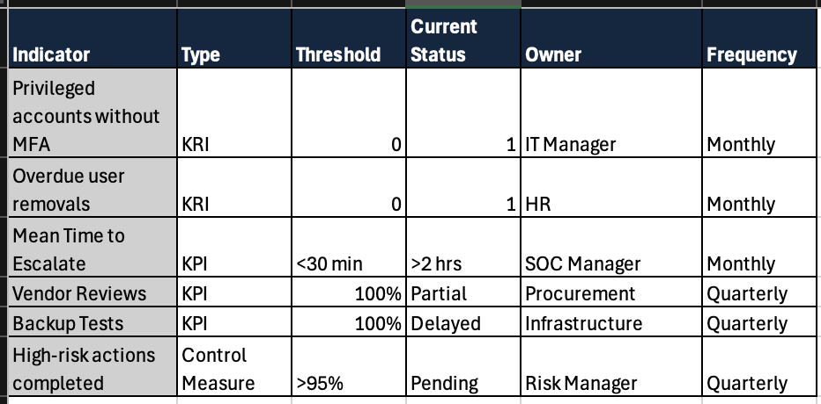

7.2 Dashboard Interpretation
Based on the evidence provided, several indicators would currently fall outside the recommended thresholds.
The presence of a shared administrator account and a documented multi-factor authentication exemption indicates that the organisation would not achieve its target for privileged account security. Likewise, the contractor account that remained active for 37 days demonstrates weaknesses in the offboarding process and would be reflected in the indicator tracking overdue account removals.
Incident response metrics also require improvement. Although suspicious activity was detected early, escalation to management and containment were delayed, suggesting that the current Mean Time to Escalate exceeds the proposed target. Improving response procedures and clearly defining escalation responsibilities would strengthen operational resilience.
Vendor governance is another area requiring management attention. While the customer support provider has obtained a SOC 2 Type II report, the absence of documented contract reviews and incomplete contractual clauses means vendor assurance cannot currently be considered fully effective.

7.3 Assurance Activities
To maintain confidence in the effectiveness of the GRC programme, management should establish a structured assurance process that includes:
- Quarterly access reviews for privileged and high-risk accounts.
- Annual independent reviews of third-party suppliers.
- Scheduled testing of incident response procedures.
- Regular internal audits covering governance, access management and data protection.
- Annual review of AI governance controls following deployment.
- Periodic reporting of key GRC indicators to executive management and the Board.
These assurance activities will help verify that controls continue to operate as intended and that corrective actions are completed within agreed timeframes.

7.4 90-Day Improvement Roadmap

Phase 1 – First 30 Days
Priority: Critical
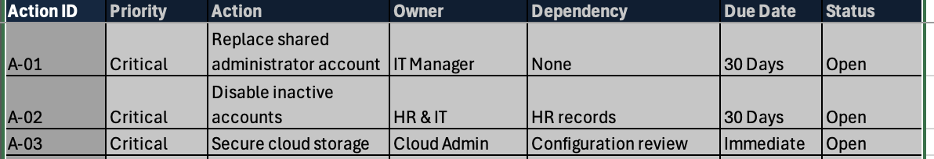

Phase 2 – Days 31 to 60
Priority: High
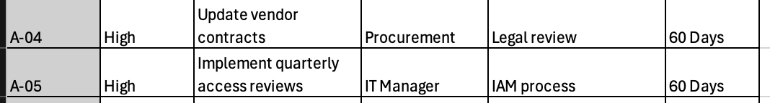

Phase 3 – Days 61 to 90
Priority: Strategic
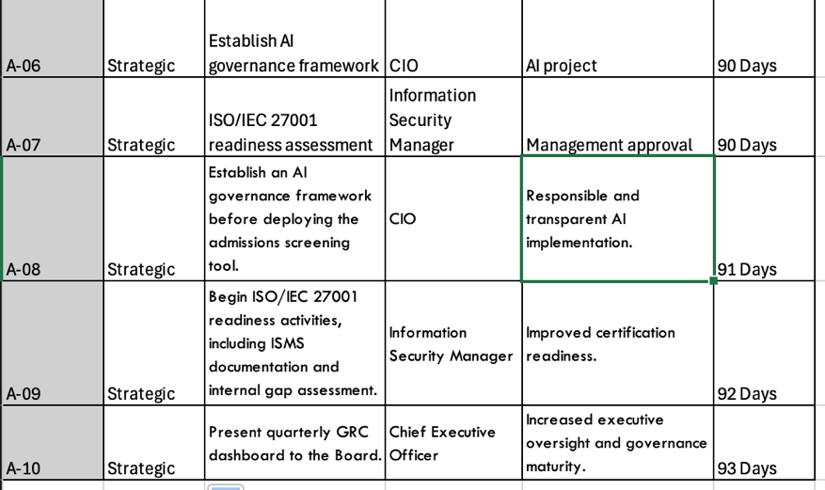

7.5 Expected Outcomes
If the roadmap is implemented over the next 90 days, NexaLearn should achieve several measurable improvements:
- Elimination of shared privileged accounts and inactive user accounts.
- Faster detection, escalation and containment of security incidents.
- Stronger oversight of third-party service providers.
- Improved readiness for ISO/IEC 27001 certification.
- Better alignment between business growth initiatives and governance objectives.
- A governance framework capable of supporting the planned AI-assisted admissions system.
These improvements will not eliminate risk entirely, but they will significantly strengthen NexaLearn's governance maturity and support the Board's strategic objectives.

Consultant's Note
One of the most encouraging aspects of this assessment is that many of the identified weaknesses can be addressed through improved governance rather than major technology investments. Clear ownership, consistent processes and regular monitoring will likely deliver immediate benefits while laying the foundation for long-term compliance and operational resilience.

